**PRACTICAL NO: 08A**

**AIM: Simulate Mobile Ad-hoc Network with Directional Antenna**

**STEP 1:** Consider the following Topology.

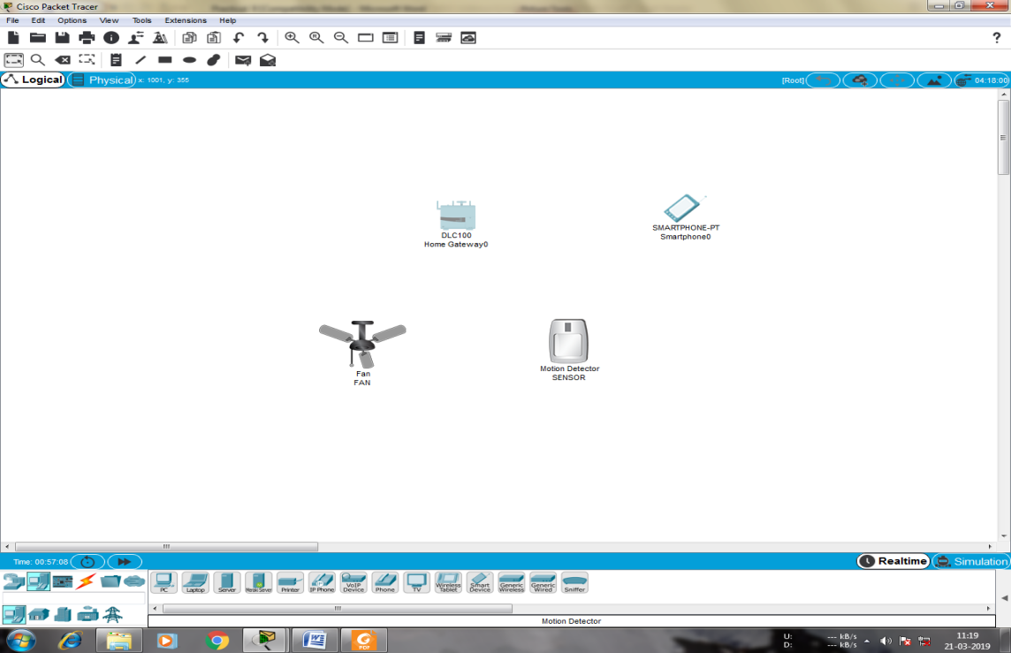

**STEP 2:** Click on the Fan and do the following

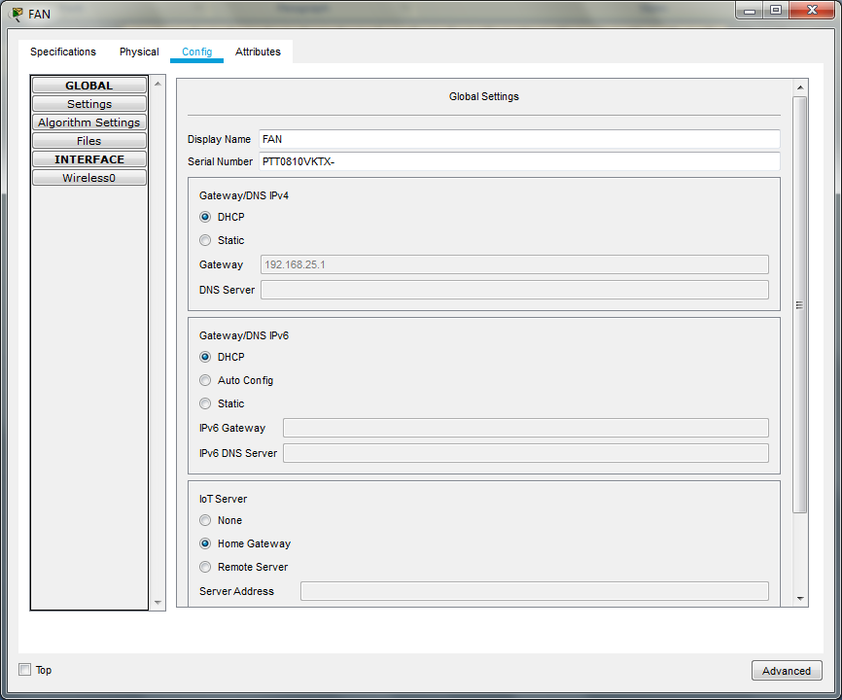

**STEP 3:** In the Advanced setting do the following for the Network adapter

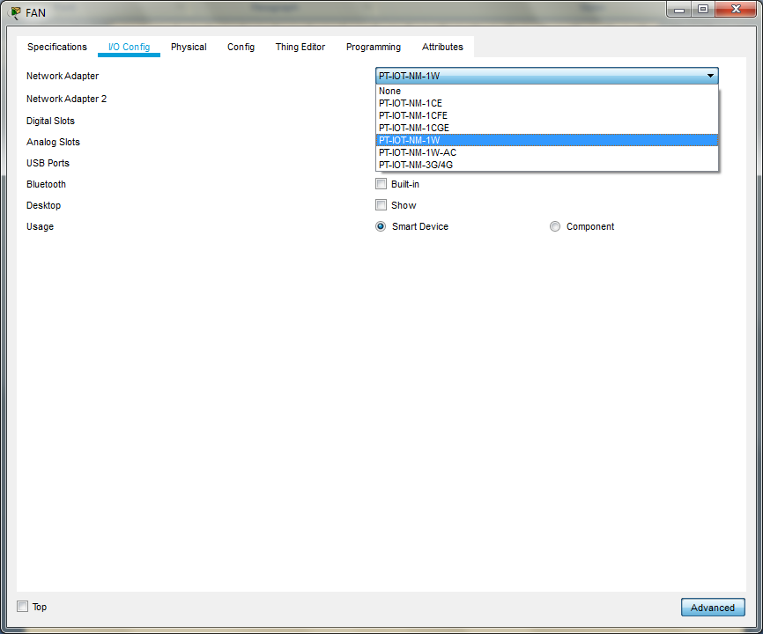

**STEP 4:** For the motion Detector sensor do the following

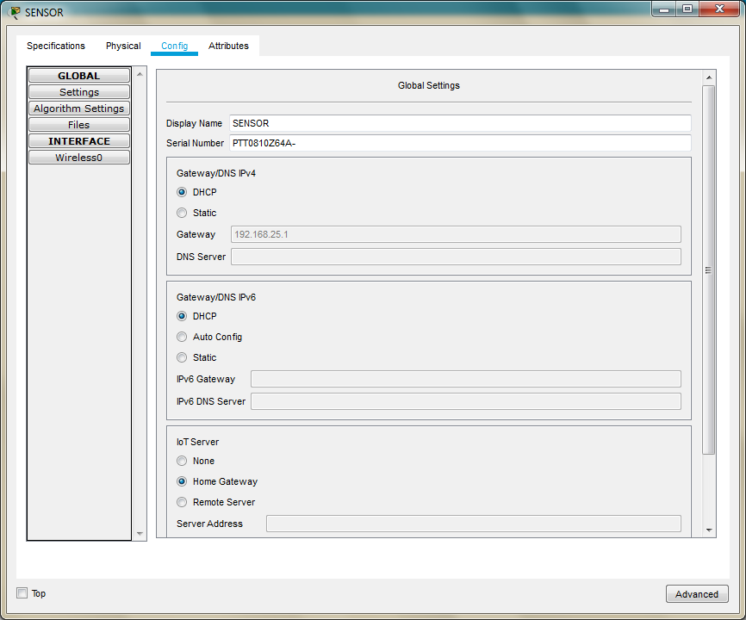

**STEP 5:** In the Advanced setting do the following for the Network adapter

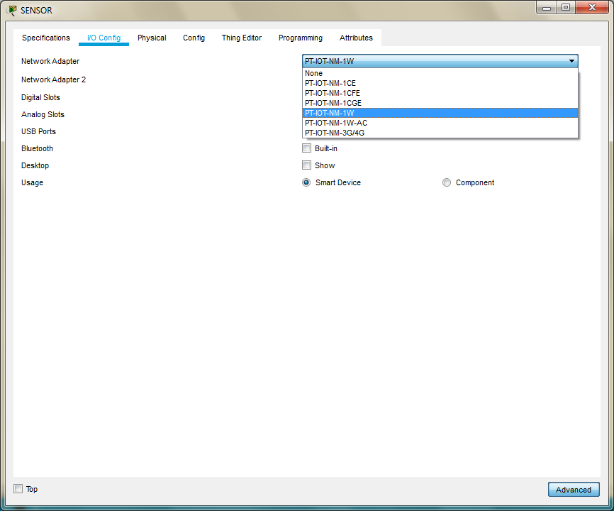

**STEP 6**: For the smartphone change the SSID to the SSID in the Home Gateway0

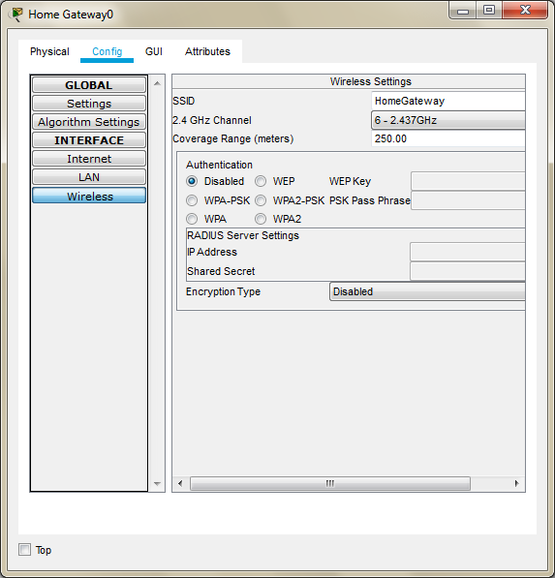

**STEP 7:** As seen above the SSID is HomeGateway, we use the same and set the SSID in the Smartphone

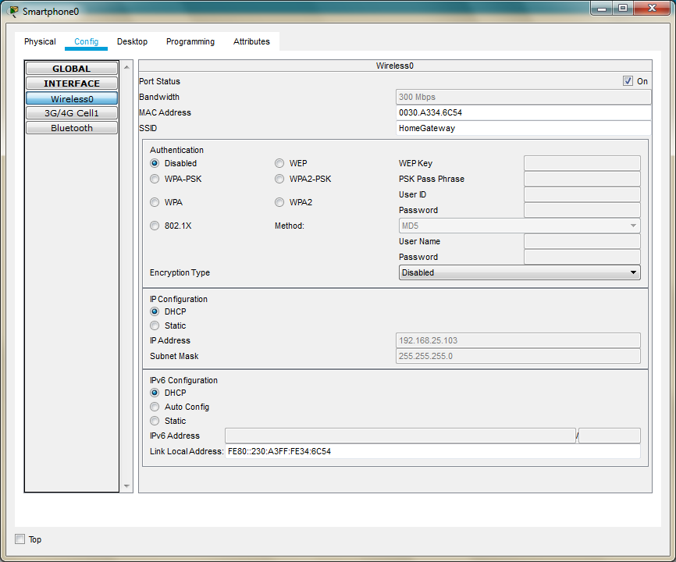

**STEP 8:** All the devices are now connected to the Home Gateway

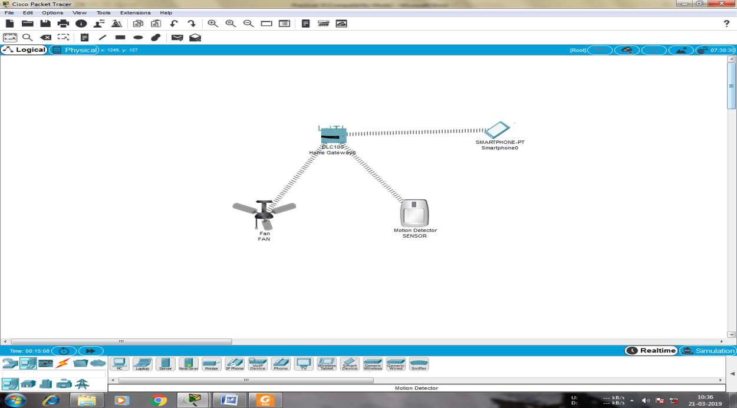

**STEP 9:** Now open the Web browser of the SmartPhone and type the IP address of the HomeGateway

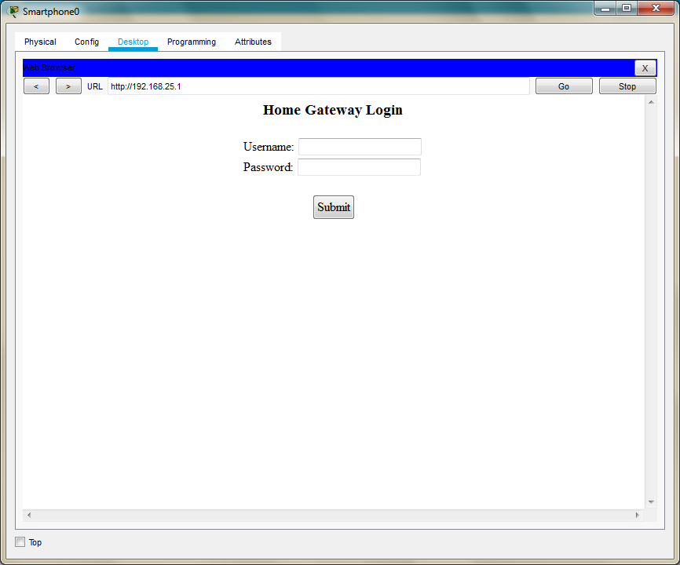

**STEP 10: Username: admin**

**Password: admin**

**STEP 11:** After logging click on conditions and do the following

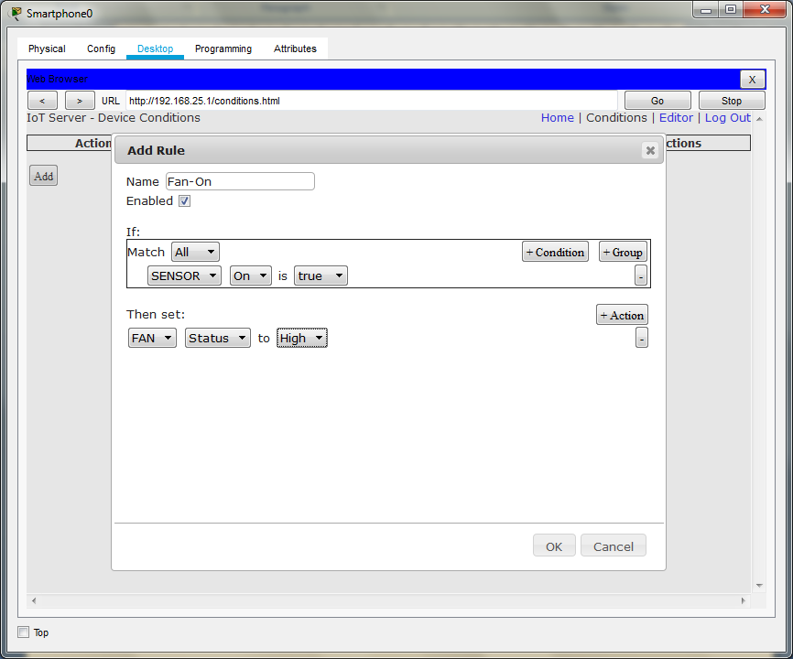

**STEP 12:** Add another condition as follows

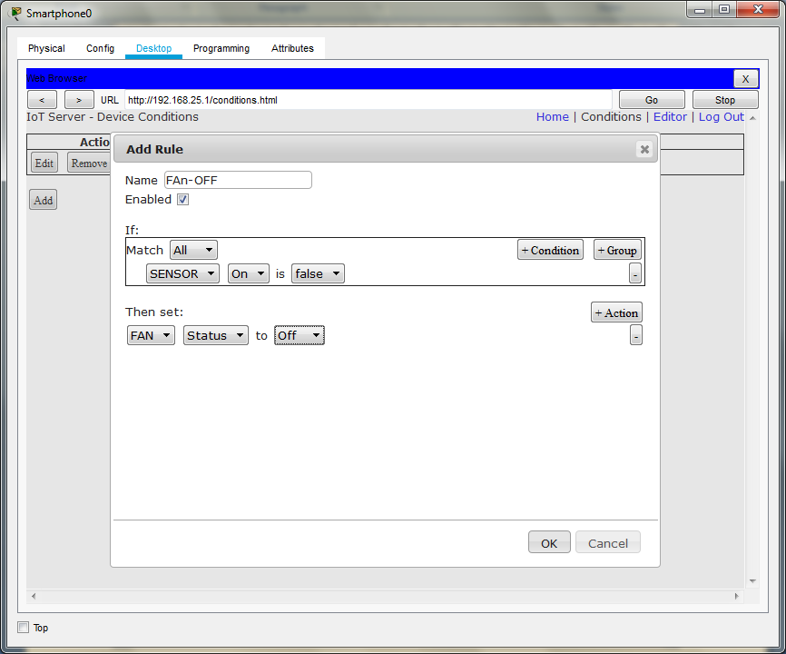

**STEP 13:** Press the go button after adding the two conditions

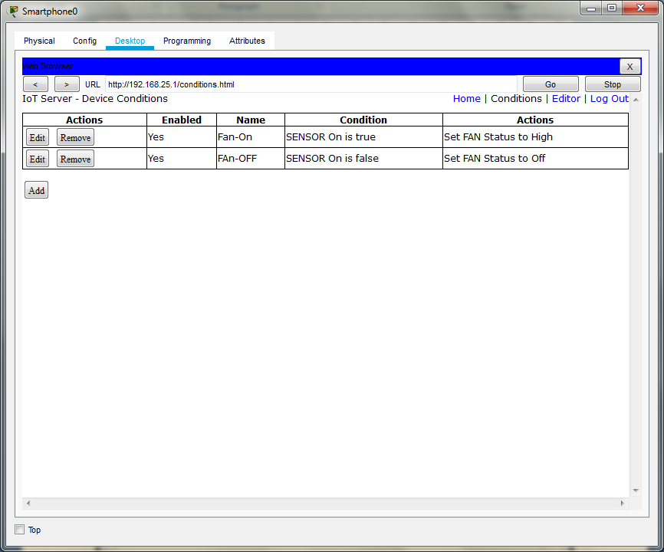

**STEP 14:** In order to turn ON the fan Press the ALT key and left-click the mouse over the Sensor

